HMIS Advisory Committee Meeting
1/14/2025

Attendees

- Racquel McGlashen
- Tim Reed
- Aaron Lewis – Family Support Network
- A Crocket
- Adrian Grant
- Brad Sefter
- Chrissy Moore – SRC
- Dave Conley
- Dave Conley
- DCharles
- Erica Medina
- Gleide3640
- Greg Carter
- Ixchelle Hicks
- Jorge
- Juan Correa
- Karen
- Keisha Wright – Anthony House
- Kenland – Family Promise
- Latoya Hazle
- Laura Sanchez – CLS
- M Chantal Lysse
- Marlo Pearson
- Melissa Sandel
- Moesha Herron
- N Villa Roel
- Olga Gonzalez
- Pamela Ford – Clean the World
- R Borgognone
- Sara Santiago – Church & Community Assistance Inc
- S Gilmore
- Shantel – Pathway Homes of FL
- Sheila Beaty – Pathlight Home
- Taraya Budhram
- Tiffany Ware
- Tino Paz – HSN HMIS
- Warren Foster
- Y Shelton-Edmonds
- Zeus – Pathlight Homes

Call to order: Racquel McGlashen
Committee Roll Call:
- Melissa Sandel (Christian Service Center)
- Brad Sefter (HCCH)
- Danielle Landaal (IDignity)
- Keisha Thomas (Anthony House)
- Caren Olsen (Covenant House)
- Karen Jackson (Zebra)
- Nancy Martinez (SRC)
- Brittney Behr (HMIS Team Liaison)

Approval of minutes from 9/10/2024:
- Motion: Karen
- Second: Brad
Agenda Approval:
- Motion: Karen
- Second: Brad
New Hires: Introductions
- Gregory Carter
- Moesha Herron
LSA Submission Review
- Longitudinal Systems Analysis
- Many less issues this year
- Process of submitting it identifies system-wide issues
  - Overlap issues with ES & TH Projects
  - Child-only households
  - Missing Enrollment CoC values
- Data Analysis Tool (EVA) – using it in tandem with the LSA report. Helped identify those issues
- Please make clean-up a priority
PIT Announcements
- Starting on 1/27/25 (Monday night) – starting sheltered count
- 1/28 – 1/30: unsheltered county
- Volunteer opportunities
  - Locations available in Orange, Osceola, and Seminole counties
  - 3.5 hour shifts
- Helps HUD determine what our community needs
- IDignity mentioned that IDignity may be a good place for a team to stop by
- Tiffany Ware: asked what to expect. Teams will be asking questions of unhoused individuals
- Danna offered CCAP via chat – they’re a warming and cold station. They have a shower bus, so many unhoused attend
- Melissa Sandel: will we be counting individuals who are living in cars? Angel will do more research
- Key findings from 2024 AHAR PIT count
  - Report to congress regarding the current unhoused situation
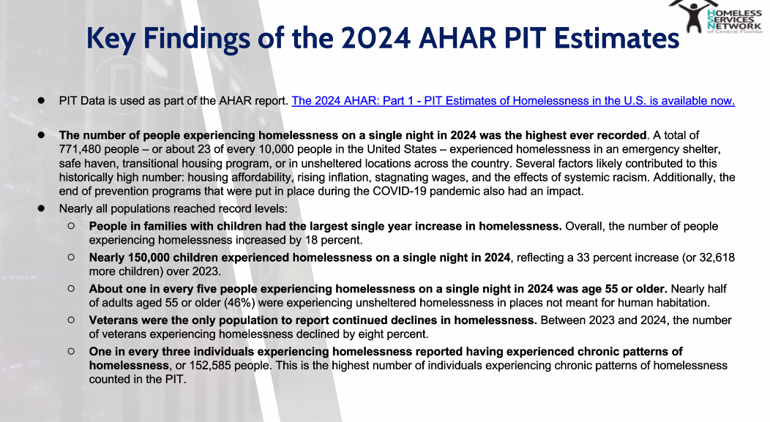HIC Reminder
- HMIS Lead team must also prepare the Housing Inventory Count (HIC). If a provider manages projects with beds:
  - Respond back to any questions about bed inventories from HMIS team
  - Ensure exits are completed in a timely fashion
  - Review any clients with stay over 300 days (could mean a missed exit)
  - For housed clients in RRH & PSH, ensure there is a housing move-in date present
  - Make sure demographics are complete for all enrolled clients – race/ethnicity, age, gender, veteran status
Deceased Client Workflow – Revisit
- Recommendations for Effective Communication & Notification Methods
- Develop a systematic approach for notifications to case managers
- Ensure timely updates in HMIS
- Improve data accuracy and recordkeeping
- How can we do this? Options:
  - Display deceased status on Client Dashboard (regular font)
  - Email notifications to all active projects/agencies
  - Alerts when accessing deceased client records
  - Generate regular deceased client reports
- How do we make this decision based on what the CoC is looking for?
- Suggestions/questions
  - Danielle: Send alert to all open enrollments? Yes
    - Brad, but if an enrollment has been closed out, we need other way to see it
  - Brad: display on the dashboard would be helpful. Although it is hard to see, we know that we need to know if they have passed so that we can know which clients to focus on and to update data accurately
  - Dave Conley: would this process work for all family members, not just head of household? This would affect eligibility.
    - Brad: does HMIS change the next person to Head of Household? Angel: when you do the exit, it gives the opportunity to change Head of Household
  - Deceased client reports helpful for street outreach. Will prompt case managers to report any that are missing, as well. Could be helpful to send it out, but HMIS would probably have it available on demand.
    - Dave Conley: helpful because then can pull when we need it
- If you have any questions as to how to handle the submission of a deceased client, send email to HMIS. They can help
- Next steps: HMIS will review this feedback and present at next meeting
New Videos: HMIS 101 Instructional, Client Access Rights, ROI
- Routine Training Calendar
  - 1st & 3rd Tuesday: HMIS 101 New
  - 2nd & 4th Wednesday: HMIS 101/102 Refresher
  - 3rd Tuesday: ClientTrack Introduction to Reports Training
- Ad-Hoc Reports Training (request via HMIS Support)
  - APR/CAPER
  - Everyday Reporting
  - Explore Data Explorer
  - Data Quality Workshop
- Office Hours: M/W 1-2pm
- Reminders:
  - If you are the Agency Liaison:
    - Request all new user training requests
    - Let HMIS team know when somebody leaves the agency so their account can be deactivated
- Karen: How do we know how many licenses we have? Tim is working on that right now. Watch for an email in the next few weeks about this.
- Data collection templates are on the website
  - Also training manuals
- New videos
  - HMIS 101 Self-Guided Training – Instructional Video
    - Provides quick breakdown of training expectations before they begin the course
      - Trying to increase number of training completions
      - Reduce confusion around the participation component of the training
    - Feedback:
      - Karen: helpful for the agency to still have internal training in between HMIS trainings
      - If new staff member hasn’t heard from HMIS, it’s most likely that they didn’t send HMIS the client ID number from the hands-on training
  - Client Access Rights & Release of Information (ROI) Training
    - Provides an explanation fo what steps to take when client info is requested
    - Covers how our community should deal with Release of Information
    - When a client is new to the system: needs to sign release of info the first time.
      - Issue: if it’s not explained correctly, they may say no – so other agencies are no longer able to see client’s info
      - If they’re already receiving services, consent is implied
    - Review of sample conversation about how to explain client’s request to not release info
    - For more clarity, watch video through HMIS University; will be sent out to whole community
2025 HMIS Goal: Reporting and Compliance
- Data Accuracy & Integrity
  - Making a few changes in Data Quality Monitoring
- Federal & HUD Compliance
  - Reliable data reduces errors in this reporting
  - Helps maintain compliance with HUD’s data standards, and with regulations to avoid risking funds
- Funding & Resource Allocation
  - Accurate reporting that enables us to have data-driven policy decisions
- Performance Monitoring & Improvement
  - Helps track programs’ success, housing stability, service wins and gaps, strengthen accountability and transparency
- Risk Mitigation
  - Data quality issues reduced to prevent audit findings
  - Client confidentiality and data security is top priority
- Supporting Stakeholders & Community Impact
  - Ensure providers have access to data that helps us serve clients correctly
  - Helps make best next decisions

Committee Roll-Call Vote
- Nothing to vote on today
Next Meeting: 3/11/2025 10:30am – 12pm

